CSA1072:SOFTWARE ENGINEERING

LAB EXPERIMENT (DAY 2)

NAME:Cherukuri sai murali

REG NO:192211951

**EXPERIMENT NUMBER** 8: Make an Online Airline Reservation System. The activities of the Online Airline Reservation system are listed below user, admin, LOGIN, MANAGE CLASSES, MANAGE WAITING LIST, MANAGE HOLDS, MANAGE DEADLINES, LOGOUT, using this has a step-by-step process draw a CLASS diagram Draw a Class diagram for Library Management System using CASE tools

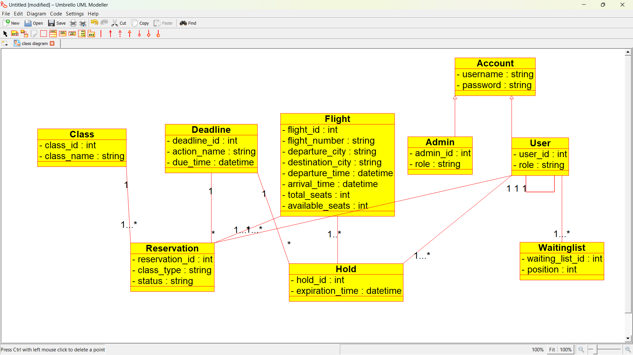

EXPERIMENT NUMBER 9: Draw a Class diagram for Online Voting System using CASE tools. eVote is an election system that facilitates voters to record their secure and secret ballot electronically. It has a friendly user interface and enables voters to cast their votes in a few simple steps. We ensure the authenticity of the voters and the votes cast by them along with non-traceability of the casted vote elaborate the whole process of e-voting.

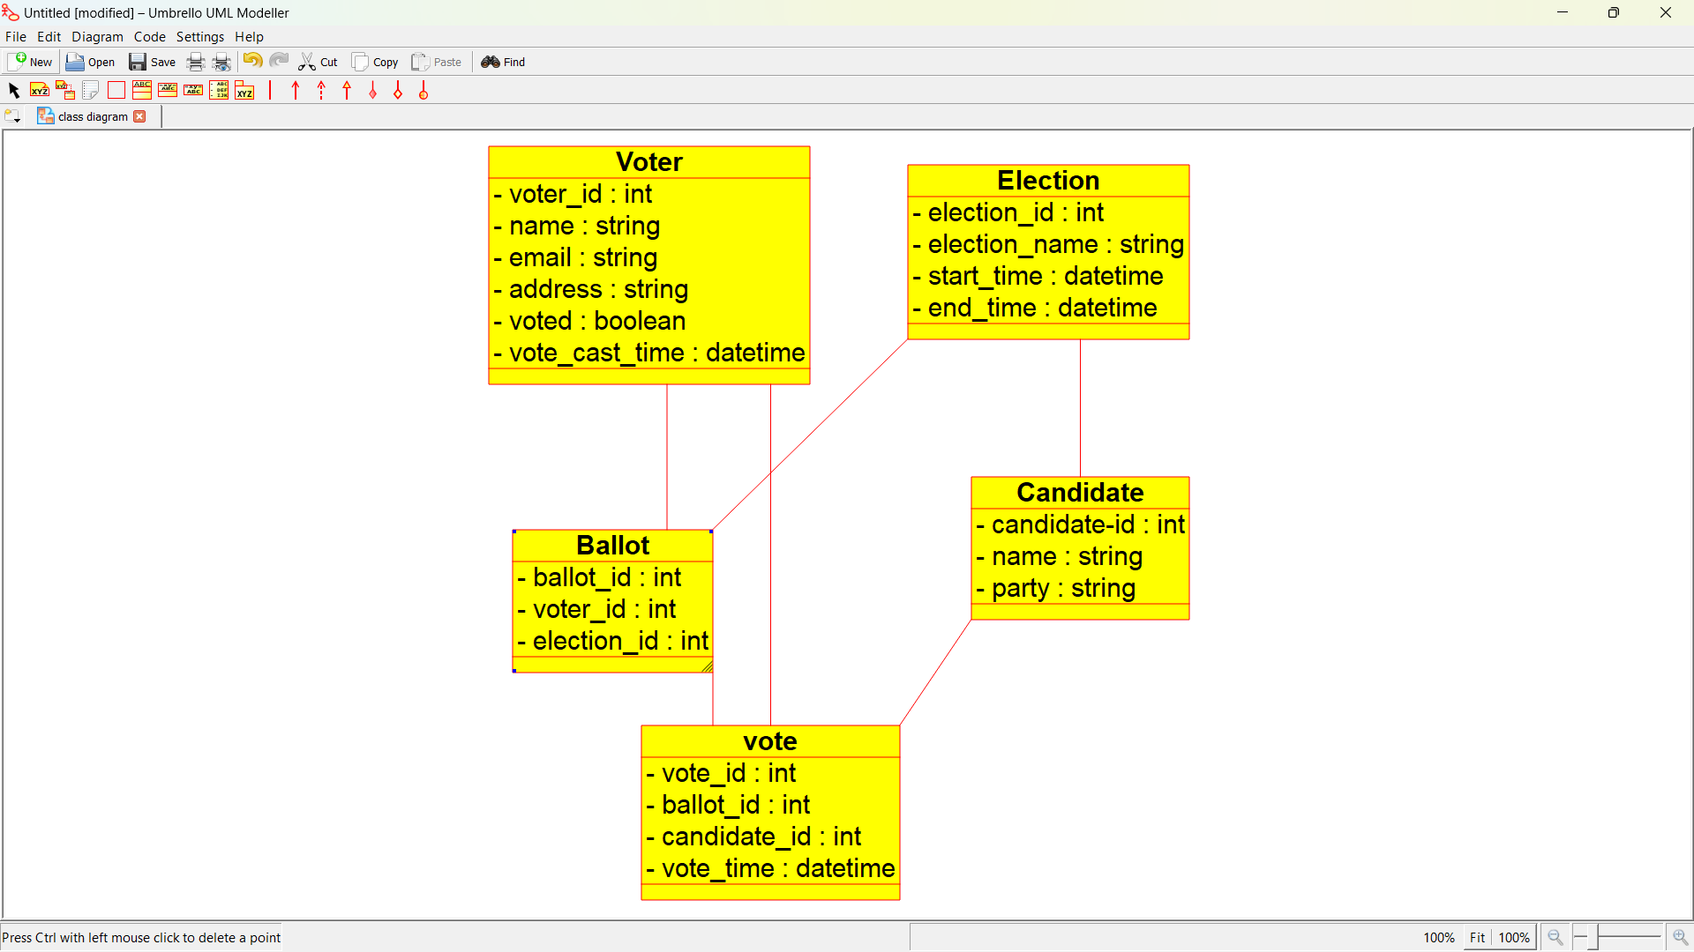

**EXPERIMENT NUMBER 10**: Draw a Class diagram for Library Management System using CASE tools. Designing use case diagram for the library management system. User who registers himself as a new user initially is regarded as staff or student for the library system. Librarians have a key role in this system. Librarian adds the records in the library database about each student or user every time issuing the book or returning the book, or paying a fine. Design the class diagram for this

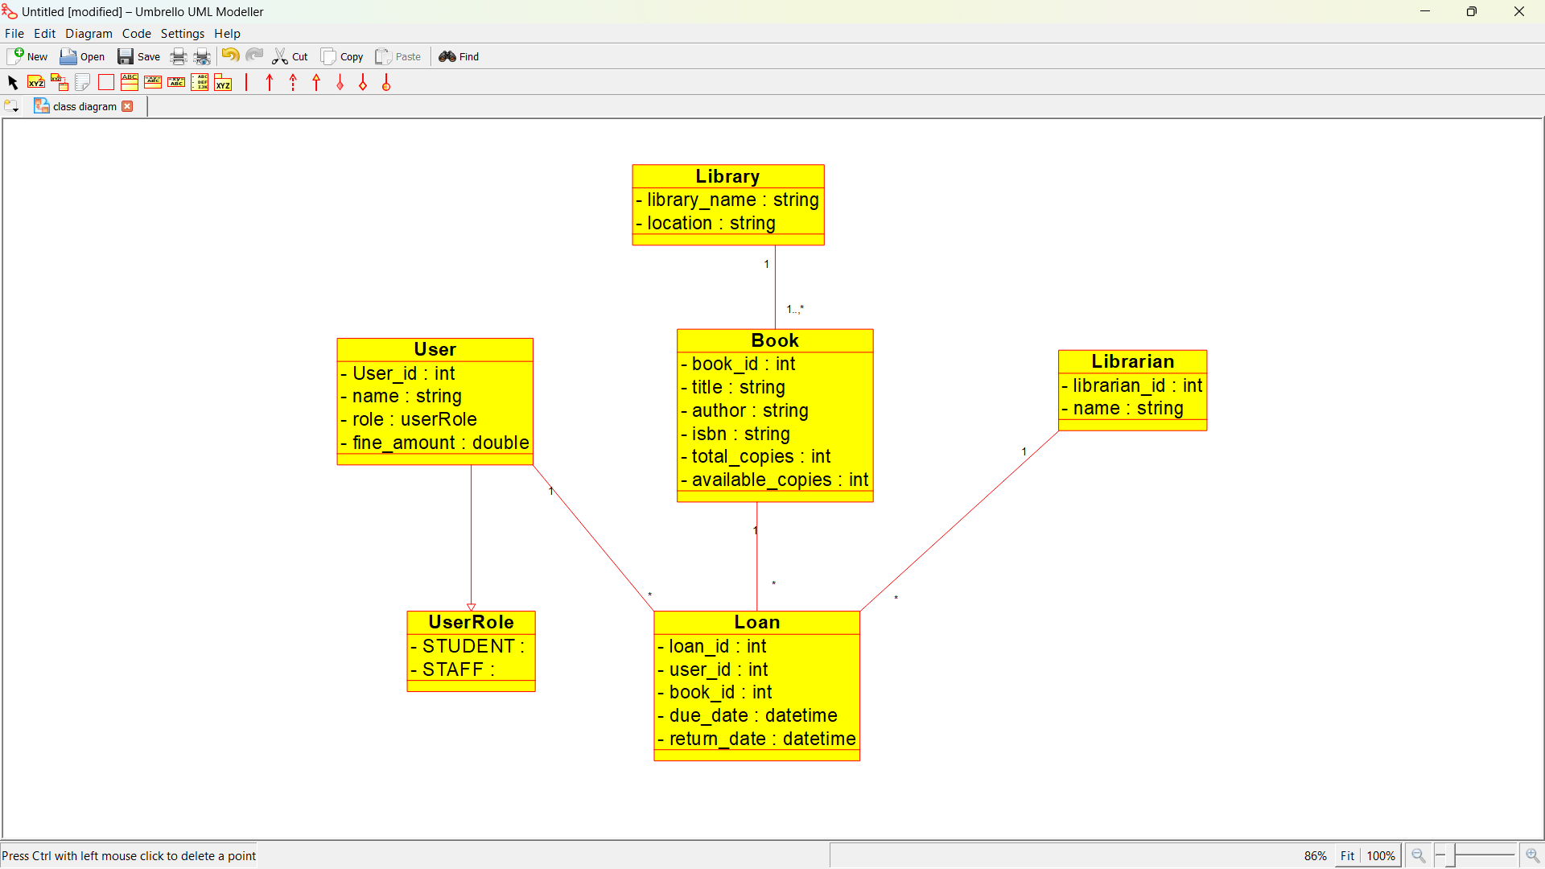

**EXPERIMENT NUMBER** 11: Draw a Activity diagram for Online Voting System for a software platform that allows groups to securely conduct votes and elections using CASE tools. The voters should be able to register via some proper authority. Construct a system in which the voters should see the list of candidates present in his constituency. A voter should be able to cast his vote to a candidate and that voter should cast only 1 vote at a time Draw an Activity diagram for Library Management System using CASE tools.

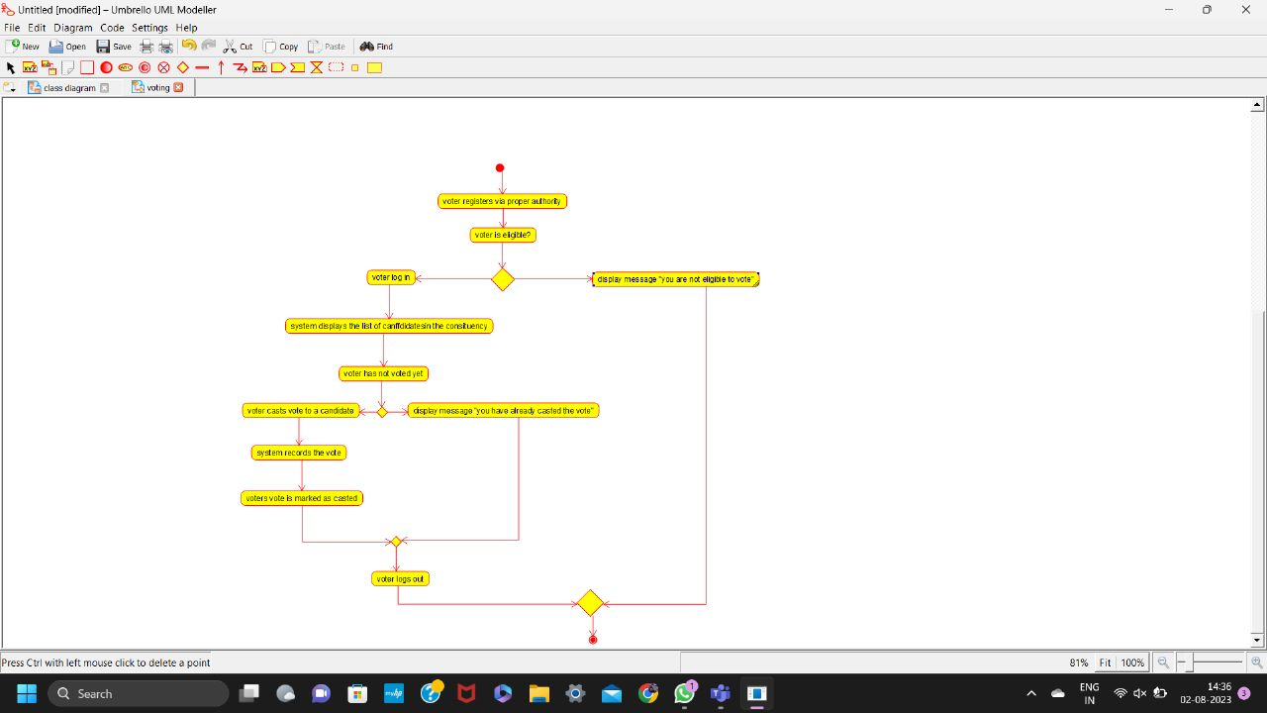

**EXPERIMENT NUMBER 12:** Draw a Activity diagram for Library Management System using CASE tools constructing User who registers himself as a new user initially who is regarded as staff or student. After getting the library card, a new book is requested by the user. After, requesting, the desired book issue the book to the user. Renew the book if the user needs the book again. Add the agent as Librarian and the user in the activity diagram

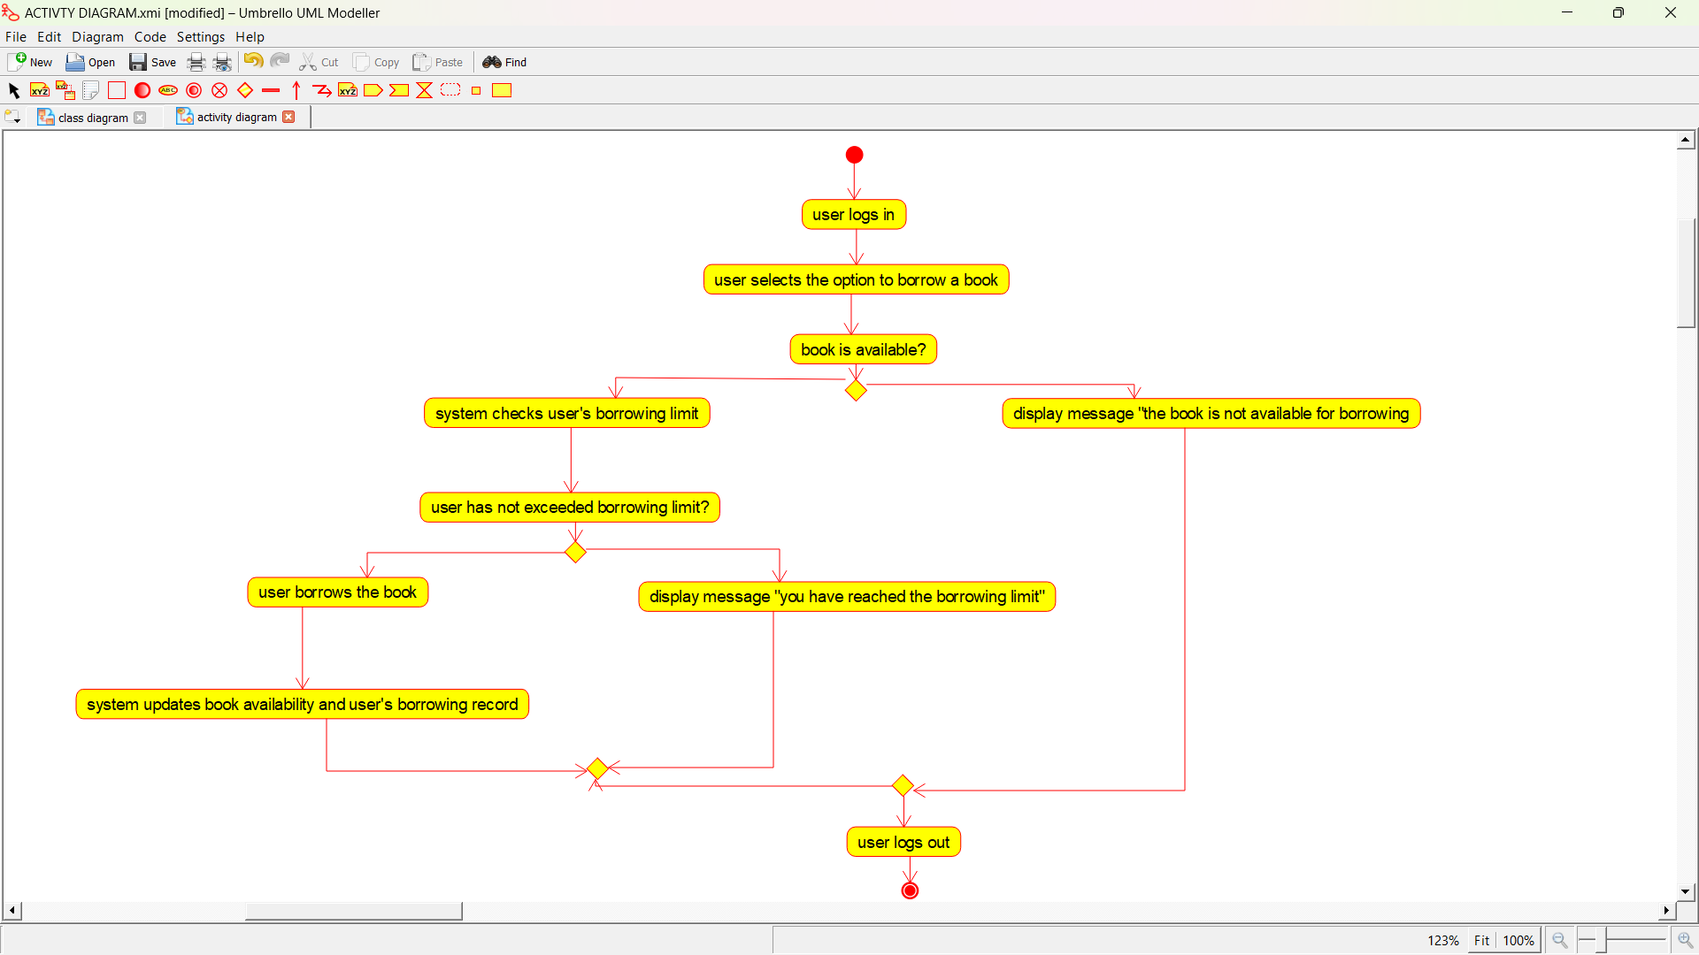

**EXPERIMENT NUMBER 13:** Draw an Activity diagram for the Online Shopping system using CASE tools with standard steps like Login, Search, Browse, add to cart, edit cart, delete cart, confirm purchase, make payments, and receive items, rate website login and logout on the system.

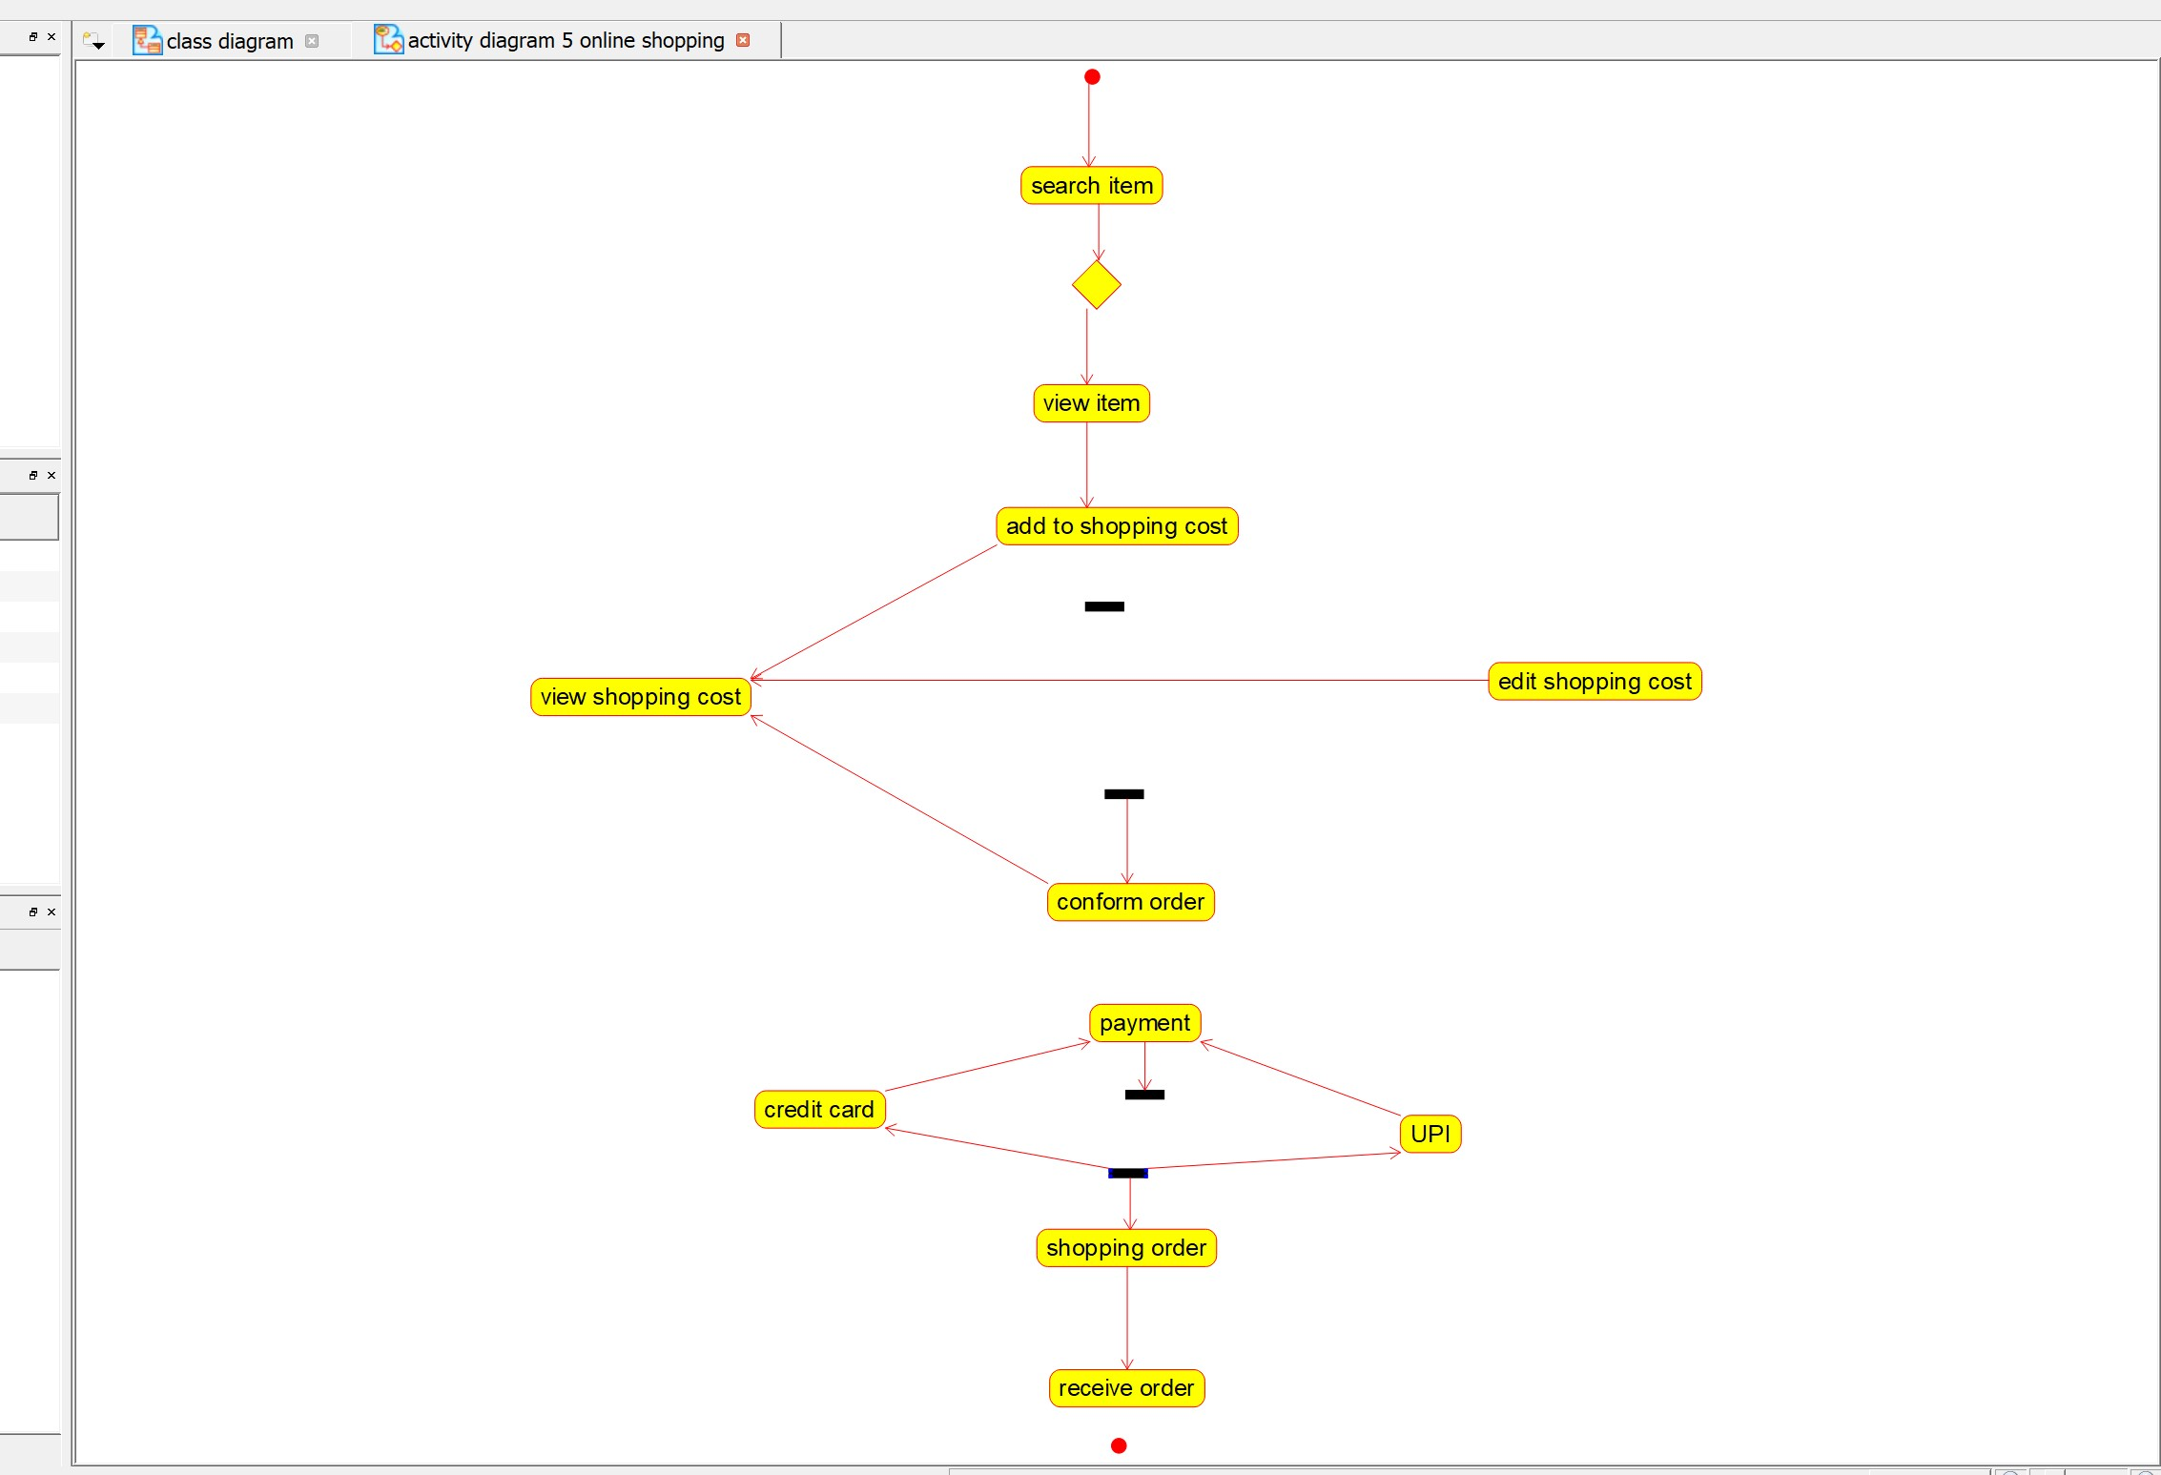

**EXPERIMENT NUMBER 14:** Draw an Activity diagram for Online Railway Reservation System using CASE tools that the two actors would be a customer and a ticket counter having search train, check availability of train, if “yes” then go to booking of train if “no” Quit the system model. Print details like make payment, print ticket, cancel ticket; refund ticket feed details like name of the passenger, date and time of journey, amount of the journey.

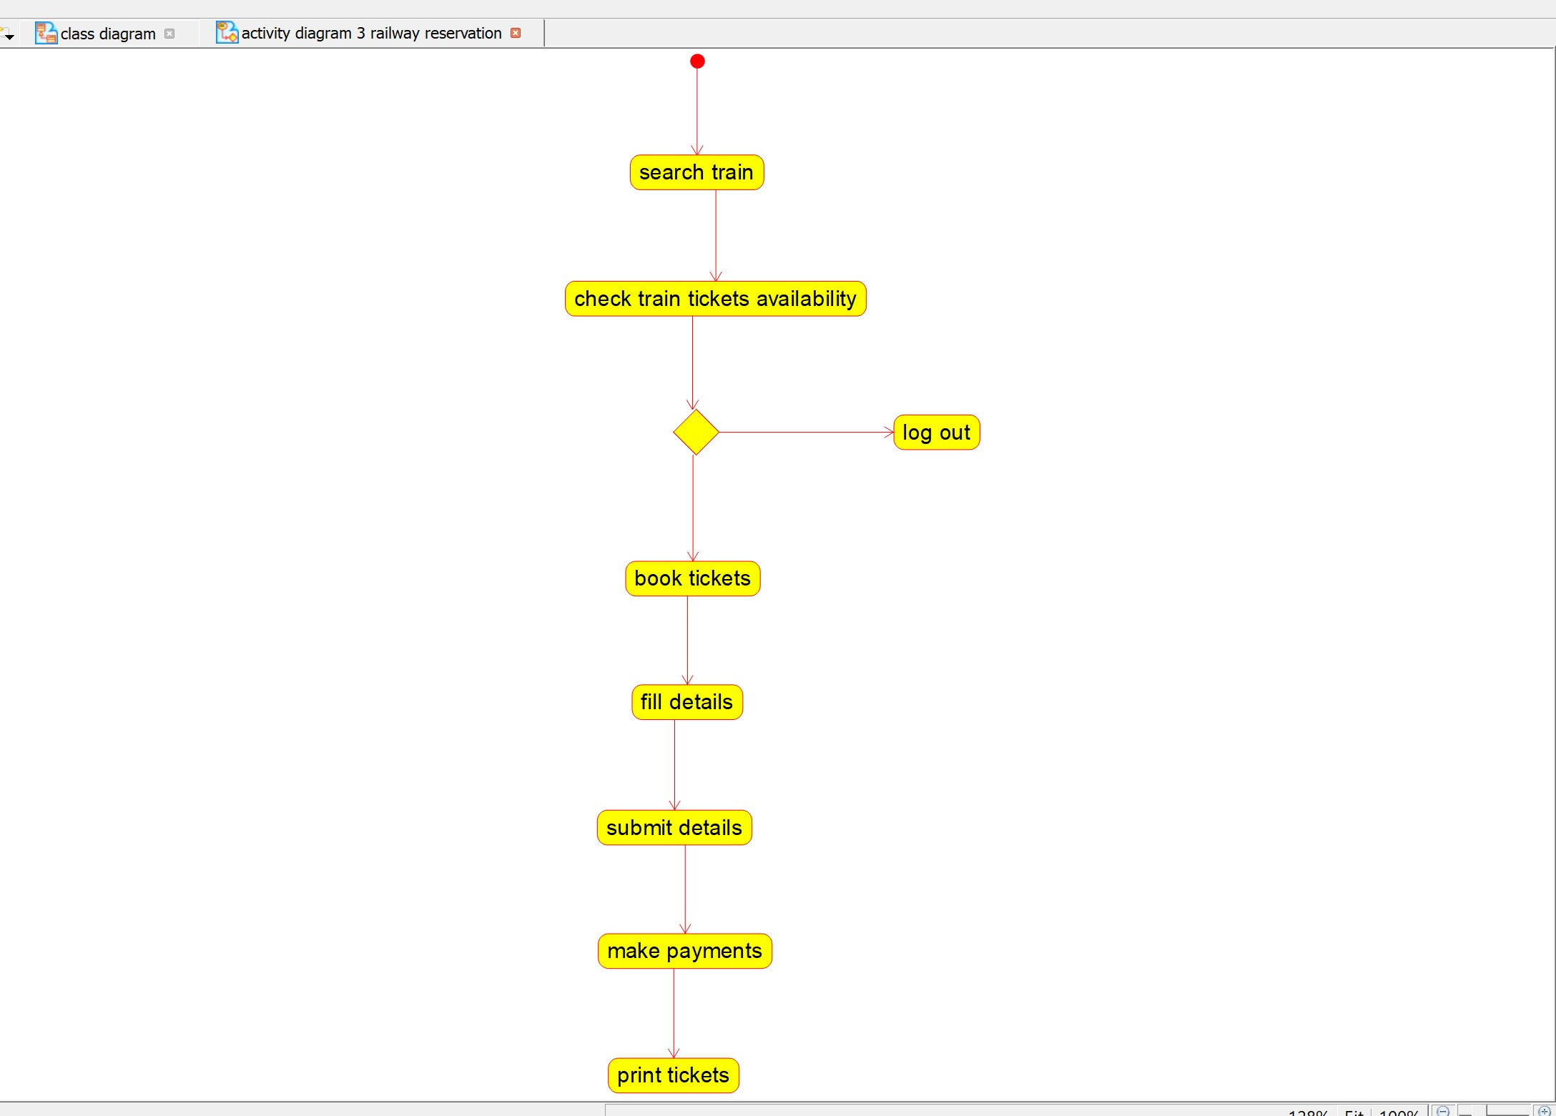

**EXPERIMENT NUMBER 15:** Draw an Activity diagram for Hospital Management System using CASE tools with Familiarizing activity Diagram Components, parts that are used to make the diagrams which determine the targeted users. Analyse the activities included plot of Hospital, Patient, Doctor, Receptionist the relationship. Show how the user, the hospital staff, can interact with the system model.

